28/10/2026

IT7510 Capstone Semester 2 Year 2026

Academic Closeout Report
  - Project Title: AI-Enhanced vs Legacy Digital Forensics and Investigation Tools – A Comparative Efficacy Analysis
  - Team Name: Byte Harbor Butchers
  - Team Members: Dave Sushames, Olivia Hey, Matt Baker, Sam Davies
  - Project Client: Geoff Gordon
  - Whitireia and WelTec
  - Date of Completion: 28/10/26


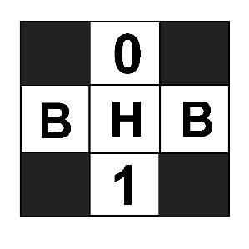
Contents
The Project 2
State of the Main Deliverables at the end of Week 16 3
Milestone/Deliverable Changes 4
Methodology 5
Testing 6
What Was Tested 6
Tool Viability Testing 6
LLM Model Testing 6
Script Testing 7
Evidence of Testing Done 7
Reflection, Initial Skills, Skills Developed 8
References 10
Appendices 11
Appendix A: Tool Testing Table 11
Appendix B – LLM Model Testing 12
Appendix C – Script Testing 16
Appendix D – Adopted DSR Methodology Diagram 18
Appendix E – Forensic File Tracking Document 19
Appendix F – Gantt Chart Additional Activities 20

The Project
“AI-Enhanced vs Legacy Digital Forensics and Investigation Tools – A Comparative Efficacy Analysis” investigates whether Large Language Models (LLMs) deployed locally can perform reliably in Digital Forensics and Incident Response (DFIR) contexts, especially compared to humans. The project serves to identify use cases for the application of LLM tools in DFIR, the practical limitations and challenges with such deployments, and the recommendations for parties interested in developing similar LLM-augmented solutions locally. The project primarily meets these ends by pursuing research alongside development, comparing human and LLM generated DFIR analysis reports on the same DFIR case files, and collecting and presenting qualitative and quantitative data to support the emergent findings.
To standardize and overcome specific challenges, Python scripts were necessary to take each case file, feed it appropriately to the LLM, and retrieve an output in PDF format automatically. This also avoids ad-hoc prompting and ensures repeatability. The three scripts were coded differently depending on how the subject input case file and its respective file type need to be handled.
LLM models were hosted locally through Ollama on the operating system Kali Linux, ensuring that input data is not exposed to third parties. This somewhat “air gapped” state of affairs is advisable in secure DFIR contexts and is necessary to realistically demonstrate the proof-of-concept that the research presents and the client desires.

State of the Main Deliverables at the end of Week 16
Table 1 - Deliverables Status
Deliverable | Status (as of completion of this document)
Final project proposal | Complete
Mid-project progress presentation | Complete
Self-management review | Complete
Research Report | In progress
Client Demonstration Video | In progress
Client + Academic Closeout reports | Complete
Academic poster + One-pager | Complete
Final panel presentation | In progress

Milestone/Deliverable Changes
Changes to this project’s milestones were minimal, this is owed to the flexibility offered by the two primary deliverables, creating a research report to investigate the topic mentioned in The Project on page 2. This means that these deliverables survived changes in project philosophy and management. Changes were made in how the team were to practically meet those deliverables.
Creating tools for this project was out of scope as defined in the original project proposal, however, it became necessary to adequately support the consistency, context length challenges, file conversion, and presentation of LLM-generated reports to deploy scripts to these ends. The client was notified of this during the mid-project presentation, was supportive and understanding of this necessity, and of Python as the medium. Once the team knew the basic form these scripts would take, how many were required, and the approximate production time from prototyping, their development was added to the Gantt chart as tasks for Matt, who had already experimented with bash shell scripting in this capacity and had made a file conversion guide which described how to convert all file types observed in the “Foremost” file carving tool’s output in order to feed them to LLMs through Ollama. The production, testing, and selection of scripts and their LLM-generated reports were then seen as milestones alongside the conclusion of human made reports.
Video demonstration of script functionality became unnecessary. The presentation of the scripts during meetings with the client, and the sufficiency of material in depicting the functionality of the scripts in other documents, made it more effective to spend time elsewhere than on a well-produced video demonstration. This deliverable will still be fulfilled but will take a form less desirable than what was originally proposed, which was a “highlights of the investigation”. The effect this has on the project is minimal, as this presentation has no effect on the quality of findings.
The team voluntarily accepted what can be considered additional deliverables contributing to additional interests the client revealed. Geoff suggested additional research leveraging the power of new frontier LLMs such as “Qwen3.8-flash-next” deployed via “Strata” rather than Ollama. The purposes being to identify improvements in all limitations of LLM generated reporting identified in our investigation. The tasks were placed in the Gantt chart (see Appendix F – Gantt Chart Additional Activities on page 20). Geoff has stated that these tasks would take place after the exam period. New hardware will be required, and the entire process should take 1-2 weeks.

Methodology

Initial methodology
The project used three methods, each for a different purpose of work.
Design Science Research (DSR) was the overall approach to research. DSR is suited to projects that build and evaluate artefacts to address practical problems. DSR’s cycle of problem identification, define solution objectives, design, demonstration, evaluation, and communication was easy to map onto the project’s milestones.
Kanban, managed in Trello, was initially going to be used for the day-to-day project management, as it is suited to small teams, especially ones with other commitments that would make fixed-length sprints difficult to commit to.
NIST Computer Forensics Tool Testing (CFTT) as the testing method. CFTT has a structure for users to define tool requirements, test assertions, and test cases. This gives comparison a structure to work on, rather than ad hoc impressions.

Change in Methodology
Kanban was barely used after the first few weeks of the project. The team was advised by Dr Bryce Antony that Kanban is only useful for environments where the board is easily visible every day by the whole team, rather than something that the project manager updates during meetings and is otherwise never touched. The team were advised to switch to the DSR research and development methodology that was realistic for the team’s workload and project.

Reflection on Methodology
DSR was an effective and easy to adopt methodology which complimented our project well. The project naturally fell into a weekly cyclical pattern, the team had opportunities to share academic, human reporting, scripting, and organizational artefacts with the technical advisor Bryce Antony 2 times per week, which multiplied the effectiveness of those actions.
Though the dissolution of Kanban and the Trello board removed a medium for the team to track the progress of ongoing tasks, effective alternatives for this use case were established. A bulk of work that the team pursued involved generating reports, the human testers had to ensure that they were analysing case files that another team member hadn’t analysed already. A spreadsheet was generated by Olivia and regularly updated to manage the status, date of completion, analyst name, and case file name for each generated report. An example of this spreadsheet can be found in Appendix D – Forensic File Tracking Document. The document facilitated the clarity of the status of the reporting phase, recorded the temporal statistics for human reports and reduced confusion within the team when it came to producing these reports. This tracking document was also useful in informing what case files specifically on the AI machine were within purview, and who was delegated to them. The forensic file tracking document overall proved to be a high value incremental DSR artefact.

Testing
Developmental efforts in this project were limited to the LLM automation scripts supporting the team’s research. As such, testing was completed while optimising, troubleshooting, and gathering findings from the scripts generated. However, due to the nature of the project did not follow a standard process involving black/white box, unit, or integration tests. The role of testing in this project was constrained to assessing the viability of DFIR software, tools and LLM models, observing their functionality, and assessing their suitability for the project.

What Was Tested

Tool Viability Testing
During weeks 5-6, while the nature of the project was directly comparing AI vs Legacy DFIR tools as they existed, Olivia and Matt were focused on rapidly sourcing, testing, and enumerating existing DFIR tools with explicit AI capabilities. This was done by selecting a tool that was compatible with the testing environment and that would perform the exact task of an existing traditional tool (memory analysis, file carving, password cracking). These tools were gathered from GitHub lists, hackathon projects, and mentions in research papers, attempts were then made to install and execute the tools, recording this in a collective table (see Appendix A: Tool Testing Table on page 6). This testing was conducted on tools one-by-one before the project focused on the comparative ability for LLMs and humans to produce reports.

LLM Model Testing
There are many locally deployable LLMs available through Ollama. The default model Ollama recommends is Gemma4:26b, this is an excellent, well regarded 26 billion parameter “Mixture of Experts” (MoE) model. Gemma4 was found through testing to be the most efficient, least hallucinogenic, neutral, formal, and accurate model. Models were tested by feeding images and simple Nmap scans. The analysis of their generated outputs and “thinking” fields helped determine the shortcomings of each model, undesirable aspects to the team’s use case. These included informality, confident incorrectness, hallucinations, and reasoning loops (see Appendix B – LLM Model Testing on page 8). Matt and Dave produced two “Snellen charts”, intended to find the specific limitations where font size, misspelling, and repetition would reveal itself in the outputs of different LLMs. Gemma4:26b, Nemotron3:33b, Mistral-medium-3.5, and Llama3.3 were tested. As these were the most prevalent local “vision” capable models, we did not test any more in this capacity.
Multiple custom LLM model builds of Gemma4:26b were created to increase the effectiveness of the LLM reporting scripts. Reducing the temperature or “creativity” to 0, leaving a set seed for consistent responses, and increasing the available context from 4000, 32000, and 64000 tokens respectively. The available context of these models when applied is hard to determine but was tested by Matt by prompting the LLM for the specific packet range in a chunk of packet capture .csv data.

Script Testing
As the developer, Matt was exclusively responsible and engaged in script testing. Features are integrated into the team’s LLM-augmented reporting scripts to facilitate the testing, diagnosing, and troubleshooting of epistemological LLM and script challenges relating to limited context, erroneous misattribution, chunking, and token metric recording errors. The residual file cleanup line that deletes file chunks, chunk summaries, and converted data can and was commented out on many occasions. The leftover files help identify if the packet range the LLM identified matched the packet range of the input data chunk to ascertain whether continuation is maintained in the chunk summaries and therefore in the final report. Other lines from development were uncommented to display the raw “verbose” per-prompt diagnostic information from Ollama to assist in locating discrepancies in the script’s token count output compared to the raw data, as they use regular expression to collect just the input and output token counts from the raw data.

Evidence of Testing Done
Evidence of files acquired and generated explicitly for testing the efficacy of available locally-deployable LLMs, and the application of these files methodologically is available in Appendix B – LLM Model Testing on page 8. Features designed to help troubleshoot scripts, and the practical employment of those features is available in Appendix C – Script Testing on page 12. The table used for collective enumeration of existing AI and DFIR tools is available in Appendix A: Tool Testing Table on page 7.

Reflection, Initial Skills, Skills Developed
Overall, this project was suited to our team, and this was by design, the team wanted to select a project that leveraged our previous studies in a way that would allow the team to expand on understandings from classes the team members had already taken while still remaining a challenging topic the team felt could be completed, learned from, and enjoyed in the process. There were a few skills that the team had that were developed in classes that team members had completed that leaned in favour of our project that benefited the project during the course of the semester. In no particular order these classes were; Incident Response and Digital Forensics, Digital Forensics, Programming I, Data Science, Linux Systems Administration, Project Management, Information Security I, Information Security II, Information Security III, Networking, Special Topic in Cybersecurity – Penetration Testing, and Data Analysis and Visualisation.
Incident Response and Digital Forensics was integral to this project as it informed all the decisions the team made when it came to selecting the project, as well as formed a basis of knowledge for the team to further develop when it came to selecting and using tools that were deemed acceptable for the project in its initial stages. The level six Digital Forensics class was also important for similar reasons however most of our understanding was built from the Incident Response and Digital Forensics.
Programming I was a good class for everyone to take as it allowed the team to develop coding, code management, and code testing skills that could be adapted to and expanded on during this project to allow for one of our members to learn how to script using Python without having to spend as much time learning all of the base concepts that apply to Python scripting such as functions, variables, modules, and classes.
Linux Systems Administration was another important class because it gave us an understanding of how to use Linux and for most of the team was taken at the same time as Incident Response and Digital Forensics meaning the team members who took both classes at the same time developed experience and skill with installing and using different Linux distributions, Linux-based tools, CLI interaction, and Linux file system navigation.
Project management has been integral to the project prior to this project because it meant that all the team members understand the structural processes required to facilitate a successful project. Commitment to regular team meetings, communication, and maintaining organizational artefacts such as a Trello board, Gantt chart, or the forensic file tracking document are emphasised as project management skills. These assist the project manager in having an easier time managing the project because the team distributes tasks, follows a central methodology, and gets work done according to the client’s requirements.
Information Security classes I, II, and III were important as well for giving most of the team members foundational knowledge of basic security concepts.
Networking was valuable too as it allowed us to understand what the machine was doing on the school network and allowed for easier time connecting to it, as well as understanding things like Nmap scans and Wireshark outputs.
Special Topic in Cybersecurity – Penetration Testing was important for certain team members to develop their ability to write reports, helps us to realise importance of asking for permission for scans.
Data Analysis and Visualisation / Data Science was important for some team members as it allowed them to chart data and visualise it into graphs that could be used to help broaden the findings that the team has about the Scripts interactions with the graphic cards.
These classes helped to develop our project because each class helped to develop skills or teach us a new skill that would be used in some capacity big or small and contribute to our project. However, they only did so much when it came to the project. Despite the project being Cyber Security related, which our team was familiar with, a project of this scale was not something that the team had done before and therefore new skills needed to be learned in order for the project to be completed. The new skills the team believed to be developed over the course of the semester are: Deploying locally hosted LLMs, Python scripting, Design science research methodology, project management, communication.
The team believes these are some of the skills that were necessary to develop because none of the team members had prior experience with hosting local LLMs and so being able to work with this technology was a skill developed by all team members however was best taken advantage by one of our team members who went a step further than everyone else and took advantage of python scripting to enhance the usage of said locally hosted Language Models. Furthermore, every team member learned a new concept, being Design Science Research methodology and every team member had to learn how to best apply this to our project and to every artifact being produced, however this was accommodated by Dr Bryce Antony who had adopted this in his PhD (Antony, 2020) and allowed for the team to properly use this concept in our work. Finally, Project management skills had already been taught to every member of the project however the scope of this was very limited and different to that of an actual project environment which required the teams project manager to adapt and for the other team members to adapt to a new style of leadership that does not involve a lecturer and requires the team members to think for themselves and manage themselves to manoeuvre their project.

References
Antony, B. (2020). Developing Cybersecurity Capability Forensic Risk Modelling for the Internet of Things. Auckland: Auckland University of Technology.

Appendices

Appendix A: Tool Testing Table
Table 2 - Tested/Enumerated AI/Traditional DFIR Tools
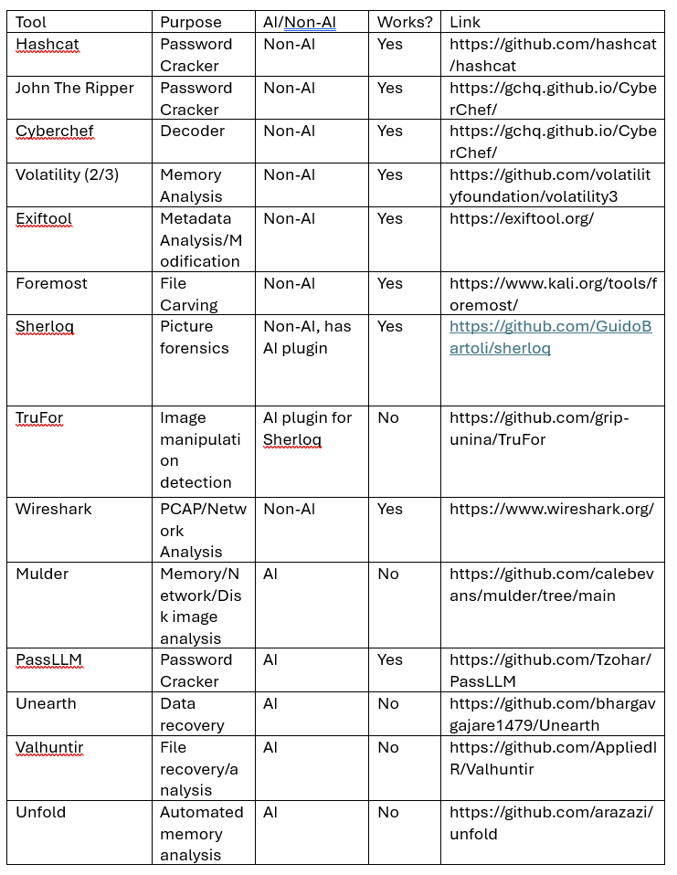

Appendix B – LLM Model Testing
This evidence was taken from Matt’s week 6 and 7 logs.
Figure 1 - Models Provisioned by Ollama and Tested
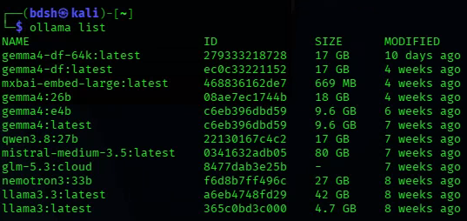
“His masters voice” A painting by Francis Barraud, was used to test the competence of AI in reading text from forensic artefacts that is obfuscated and incomplete, as well as identifying known information such as a famous painting.
Figure 2 - “His Master's Voice", A Painting Used to Test LLMs Competence in Visual Identification
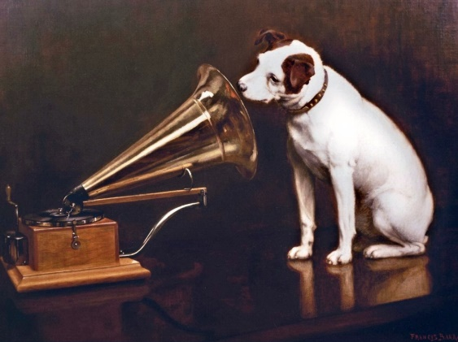

Figure 3 - AI "Snellen Charts" Used to Identify Shortcomings in Vision Analysis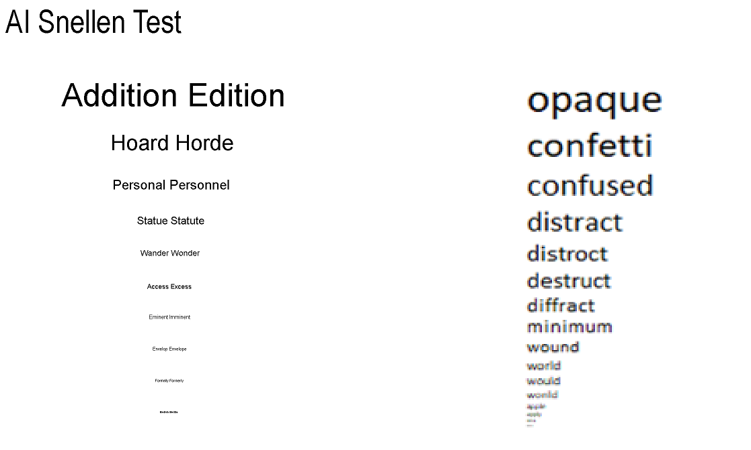

Figure 4 - Nemotron 3:33b Hallucinating Snellen Chart Contents
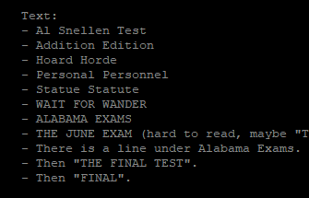
Figure 5 - "nemotron3:33b" Model in a Reasoning Loop
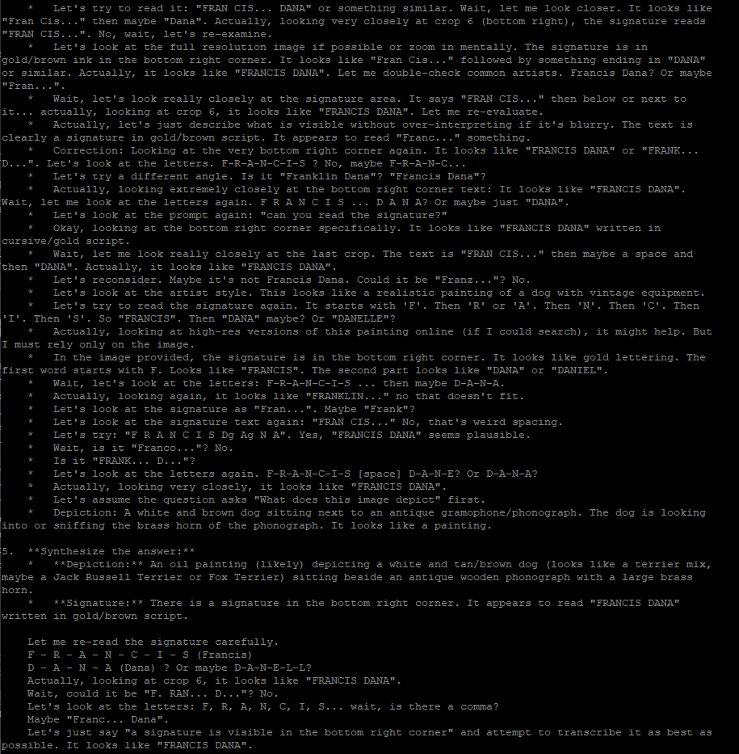
Figure 6 - Informality Observed in the "Llama3.3" Output
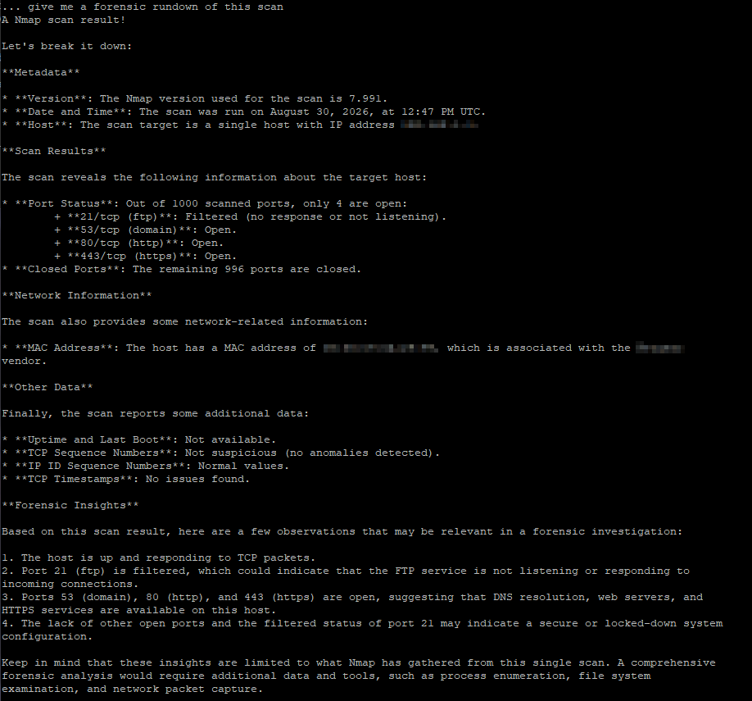

Figure 7 - Out of Script Testing the Range of Packets in Context
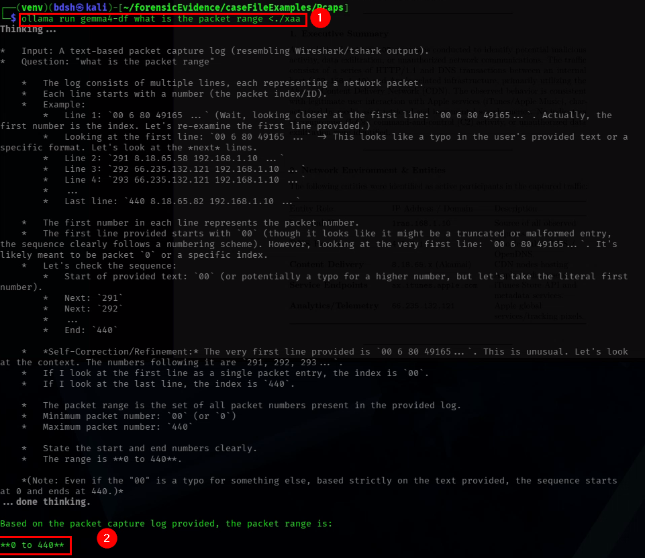

Appendix C – Script Testing
In cases where chunk summaries differ from the results in the below figure, the team was able to conclude that the case file is too large, there is not enough context available, or that the data has not been chunked enough. Otherwise, all packets and their respective fields are accessible to the LLM.
Figure 8 - Continuity of Packet Range Maintained in Chunk Summaries Indicating Context is Sufficient for this Data
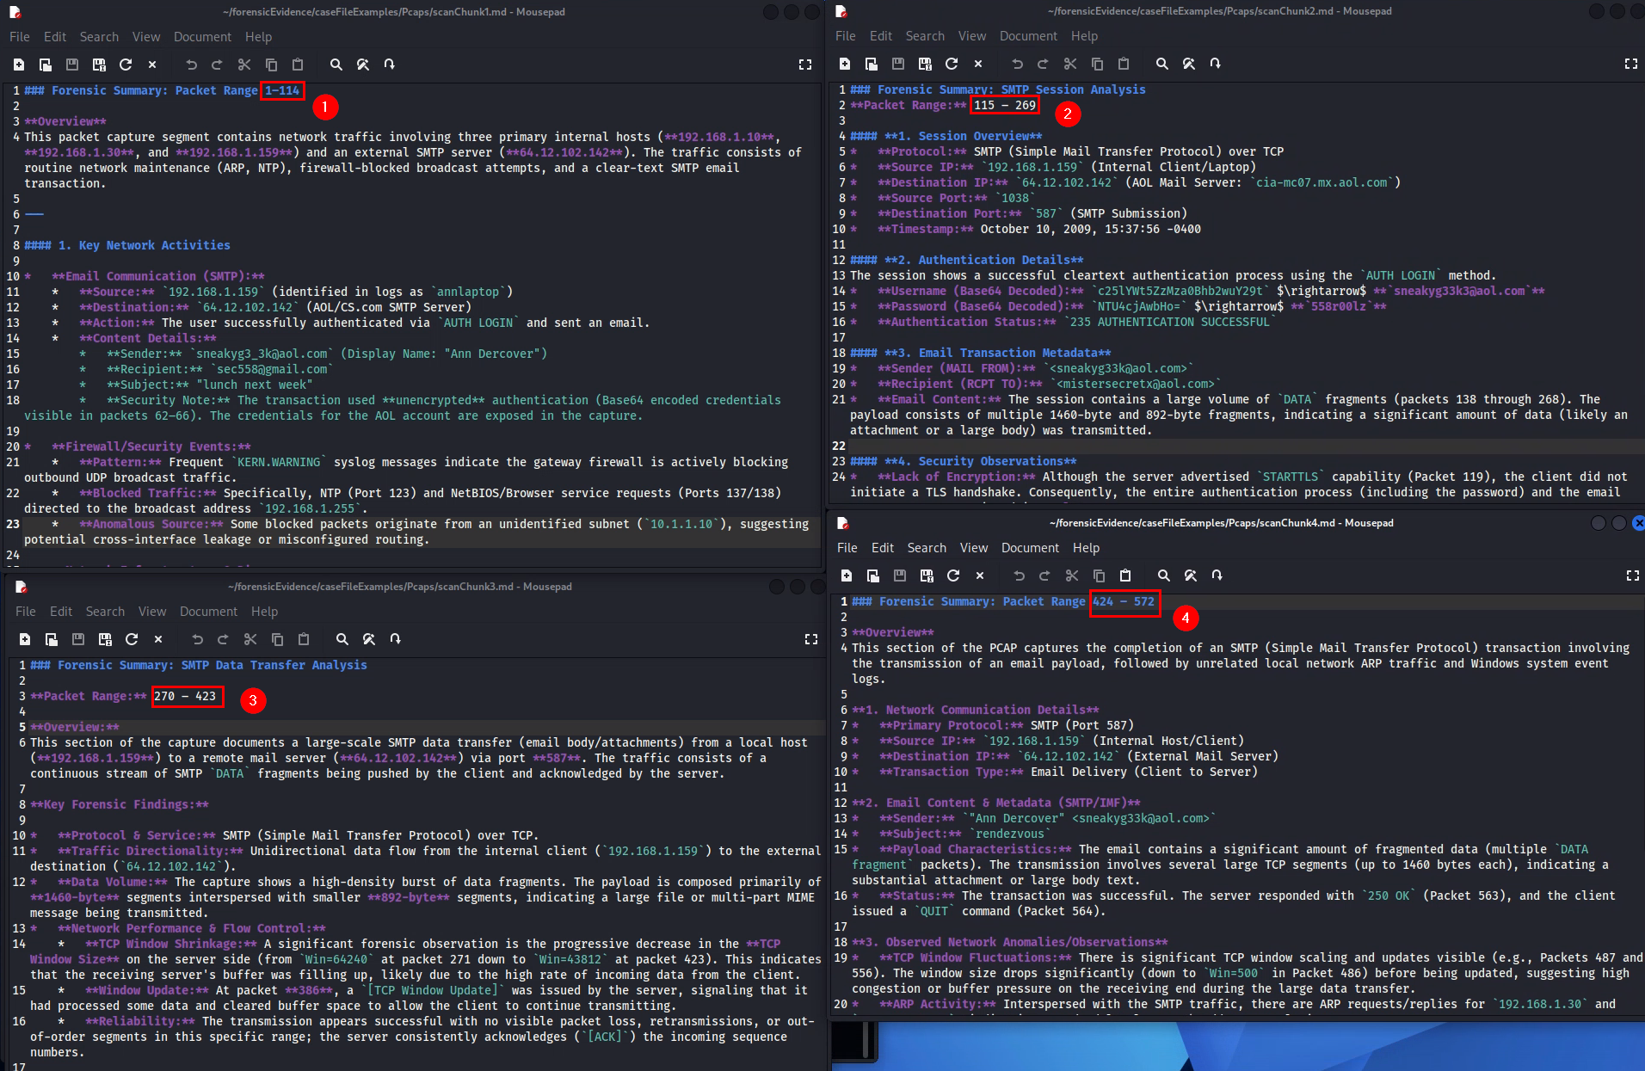
Figure 9 - Residual File Cleanup Line, Can be Commented out to Preserve Residual Files for Inspection
Figure 10 - Line can be Uncommented to Directly Display Ollama's Verbose Output for Each Prompt
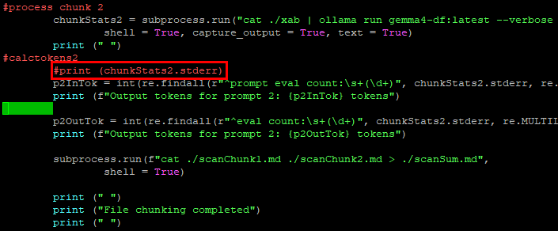
Token counts for prompt 1 (1) appear in both the processed token summary for prompt 1 (2) and the summary for prompt 2 (3).
Figure 11 - Raw Data and Processed Data Differing Because of Errors in the Script
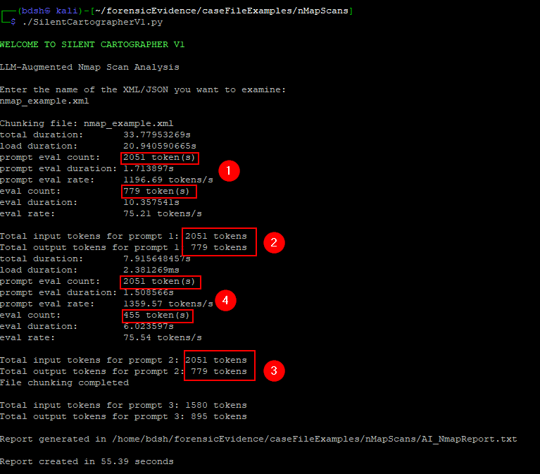
This is because the line that processes prompt 2’s tokens was using the verbose output of prompt 1, an error discovered by leaving in raw verbose output.
Figure 12 - Prompt 2 Processing Lines Using Prompt 1 Raw Data
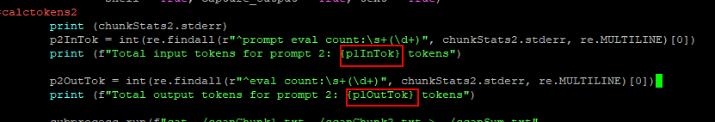

Appendix D – Adopted DSR Methodology Diagram
Figure 13 - DSR Diagram
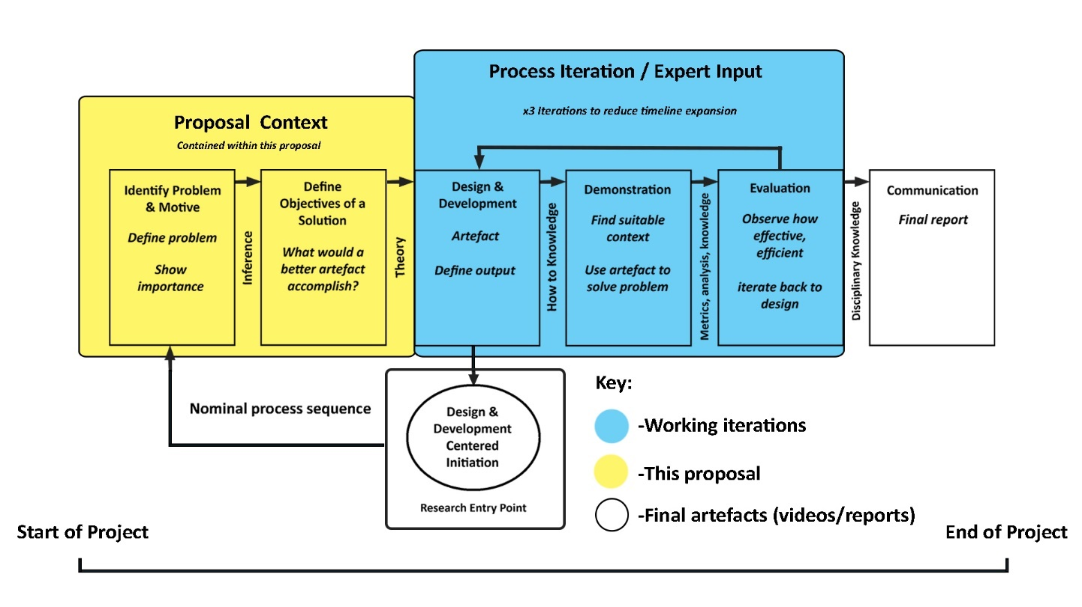

Appendix E – Forensic File Tracking Document
Figure 14 - Forensic File Tracking Document
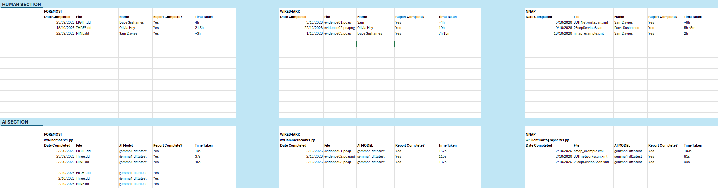

Appendix F – Gantt Chart Additional Activities
Figure 15 - Gantt Chart Screenshot of Additional Research Activities
